Create a list of tuples, where the 1st element of the tuple is an int and the second element is a string.

Example - ((1, ‘alpha’), (2, ‘beta’), (3, ‘gamma’), (4, ‘zeta’), (5, ‘omega’))

- For the above list, print the numbers where the corresponding string length is 4

- Find the average of all numbers, where the corresponding string contains alphabet ‘m’or alphabet ‘z’

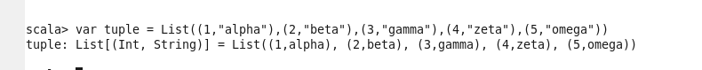



- For the above list, print the numbers where the corresponding string length is 4



* Find the average of all numbers, where the corresponding string contains alphabet ‘m’

or alphabet ‘z’



